Just A Few Children’s Books That Weave Mathematical Ideas Into Fun Stories!
By: Ms. Heather Herrig
Title | Author (Published) | Synopsis | Common Core Standard(s) Addressed
Tyrannosaurus Math  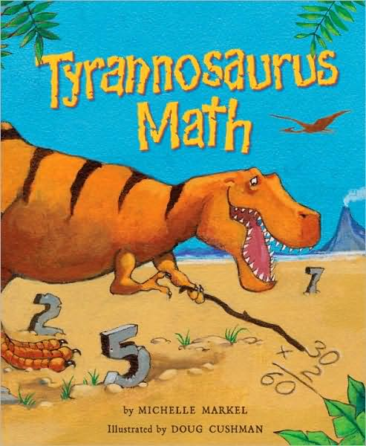 | Michelle Markel (2009) | Tyrannosaurus Math is a dinosaur who crunches numbers and chews on math problems! He counts, adds, subtracts, multiplies, and even estimates. When a little sister is in danger, it is up to Tyrannosaurus Math to save the day by using his measurable math skills! | CCSS.Math.Content.1.OA.A.2—Solve word problems that call for addition of three whole numbers whose sum is less than or equal to 20.  CCSS.Math.Content.2.OA.A.1—Use addition and subtraction within 100 to solve one- and two-step word problems involving situations of adding to, taking from, putting together, taking apart, and comparing.  CCSS.Math.Content.3.OA.A.1—Interpret products of whole numbers.
A Place for Zero  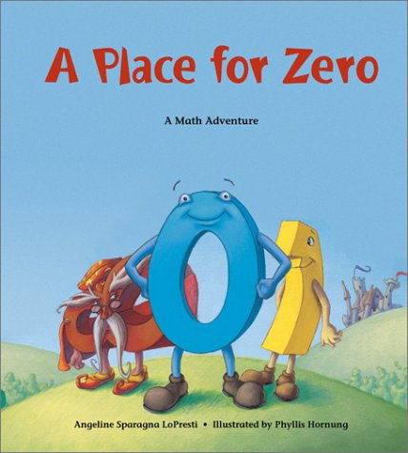 | Angeline Sparagna Lopresti (2003) | “Every number knows its place” in the land of Digitaria, ruled by King Multiplus and Queen Addeleine, except Zero felt he did not. However, Zero soon finds his place and is able to play the addition game with the other numbers. This fun book tackles addition and then proceeds to touch on multiplication and place value with the number Zero. | CCSS.Math.Content.1.NBT.B.2c—The numbers 10, 20, 30, 40, 50, 60, 70, 80, 90 refer to one, two, three, four, five, six, seven, eight, or nine tens (and 0 ones).  CCSS.Math.Content.3.NBT.A.1—Use place value understanding to round whole numbers to the nearest 10 or 100.
The Monster Who Did My Math  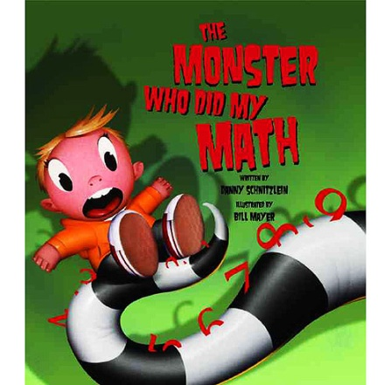 | Danny Schnitzlein (2012) | As a young boy cried out about not wanting to do his math homework, a monster appears makes a deal with the youngster. The monster did the boy’s homework, but when it comes time to solve a problem for his class, the boy is stumped! The boy is forced to use math to come up with the funds to pay off the monster who did his homework. He discovers that doing math is actually something he enjoys! As he does his own homework, the monster gets smaller and smaller until it disappears! | CCSS.Math.Content.2.MD.D.9—Solve word problems involving dollar bills, quarters, dimes, nickel, and pennies, using dollar and cents signs appropriately.
Lemonade In Winter  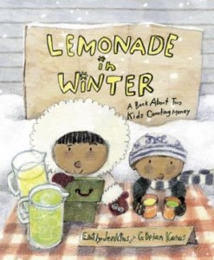 | Emily Jenkins (2012) | A sister and her little brother decide to set up a lemonade stand in the winter. They collected $6 in quarters for their supplies, but fell short of making a profit. This is a fun book that allows readers to learn about counting quarters and figuring out profits! | CCSS.Math.Content.2.MD.D.9—Solve word problems involving dollar bills, quarters, dimes, nickel, and pennies, using dollar and cents signs appropriately.
Measuring Penny  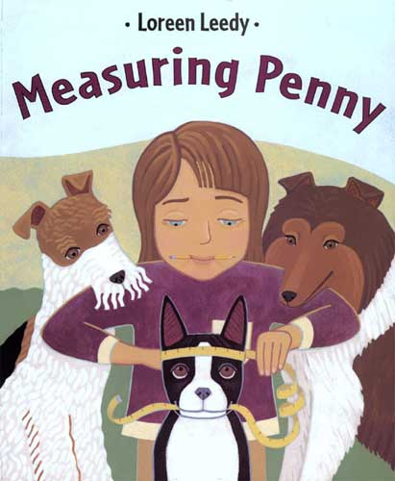 | Loreen Leedy (2000) | When Lisa is given a homework assignment to measure something in as many ways as possible, she does just that! She measured her dog, Penny, using standard units of measure (height, width, length, weight, temperature, and volume), but she went on even further and used items such as dog biscuits and cotton swabs to measure different areas of Penny’s body. Lisa even measures how long it took her dog to do things such as getting from her dog bed to her feeding bowl. Lisa incorporates her data into charts. This book seems perfect for use in the classroom and especially for introducing a lesson about measurements! | CCSS.Math.Content.2.MD.A.1—Measure the length of an object by selecting and using appropriate tools such as rulers, yardsticks, meter sticks, and measuring tapes.  CCSS.Math.Content.2.MD.A.2—Measure the length of an object twice, using length units of different lengths for the two measurements; describe how the two measurements relate to the size of the unit chosen.
How High Can a Dinosaur Count?  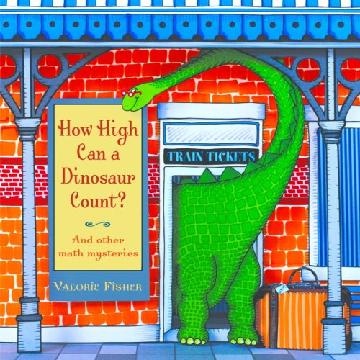 | Valorie Fisher (2010) | Heloise the dinosaur needs help adding her coins, telling time on the clock at the zoo and calculating the cost for a birthday cake! Work an array of simple math problems while enjoying a fun book! | CCSS.Math.Content.2.OA.A.1—Use addition and subtraction within 100 to solve one- and two-step word problems involving situations of adding to, taking from, putting together, taking apart, and comparing.  CCSS.Math.Content.2.MD.D.9—Solve word problems involving dollar bills, quarters, dimes, nickel, and pennies, using dollar and cents signs appropriately.
The Grapes of Math  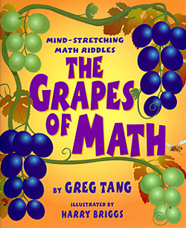 | Greg Tang (2004) | “Mama mia, pizza pie,/How many mushrooms do you spy?” Using rhyming, riddles, and visual clues, this book shares an array of techniques to help solve math problems in creative ways! | CCSS.Math.Content.1.OA.C.5 Relate counting to addition and subtraction.
The Action of Subtraction  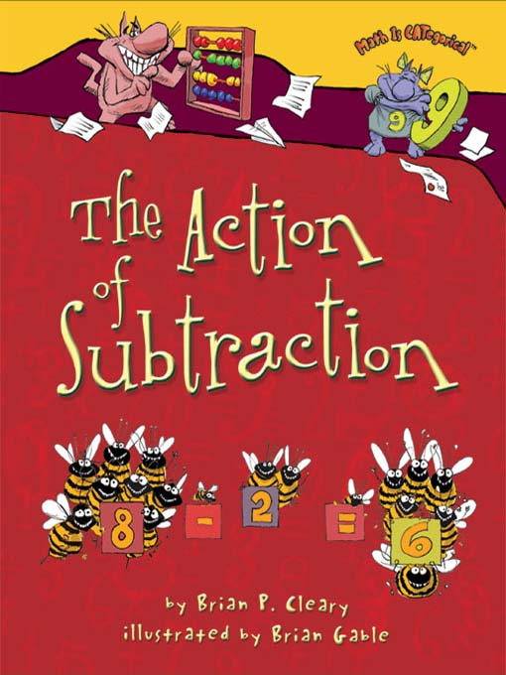 | Brian P. Cleary (2008) | The comical cats in this book show young readers the basic concept of subtraction. The illustrations and examples in this book make learning to subtract easy and fun! | CCSS.Math.Content.1.OA.C.5—Relate counting to addition and subtraction.  CCSS.Math.Content.1.OA.D.8—Determine the unknown whole number in an addition or subtraction equation relating three whole numbers.
What Time is it Mr. Crocodile?  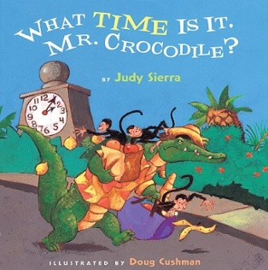 | Judy Sierra (2007) | “Time to take a quick look/for a recipe book./HURRY UP! HURRY UP!/I’ve got monkeys to cook.” Mr. Crocodile makes plans to catch and eat five pesky monkeys, but as the hours pass the monkeys continue to fool Mr. Crocodile. Children will be enjoy the rhyming text and search for clock that marks each hour! | CCSS.Math.Content.1.MD.B.3—Tell and write time in hours and half-hours using analog and digital clocks.
12 Ways To Get To 11  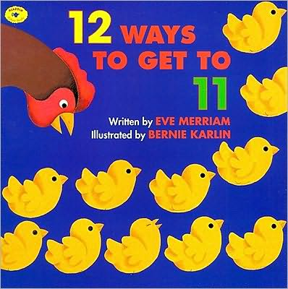 | Eve Merriam (1996) | This book takes young children on a counting adventure by integrating 12 fun and imaginative ways to get to 11! | CCSS.Math.Content.1.OA.C.5—Relate counting to addition and subtraction.  CCSS.Math.Content.1.OA.D.8—Determine the unknown whole number in an addition or subtraction equation relating three whole numbers.

References
Common Core Standards (2012). Common Core State Standards Initiative (Math). [ONLINE] Available at: http://www.corestandards.org/Math. [Last Accessed 15 April 13].
Markel, M. (2009). Tyrannosaurus Math. United States: Tricycle Press.
Lopresti, A. (2003). A Place for Zero. United States: Charlesbridge Publishing, Inc.
Schnitzlein, D. (2012). The Monster Who Did My Math. United States: Peachtree Publishers, Ltd.
Jenkins, E. (2012). Lemonade in Winter. United States: Random House Children’s Books.
Leedy, L. (2000). Measuring Penny. United States: Square Fish.
Fisher, V. (2010). How High Can A Dinosaur Count? United States: Random House Children’s Books
Tang, G. (2004). The Grapes of Math. United States: Scholastic, Inc.
Cleary, B.P. (2008). The Action of Subtraction. United States: Lerner Publishing Group.
Sierra, J. (2007). What Time is it Mr. Crocodile? United States: Houghton Mifflin Harcourt.
Merriam, E. (1996). 12 Ways To Get To 11. United States: Aladdin.

